115 epoch, 80 single dense layer

Batch size 120

Batch size 16

FNN 80 Dense

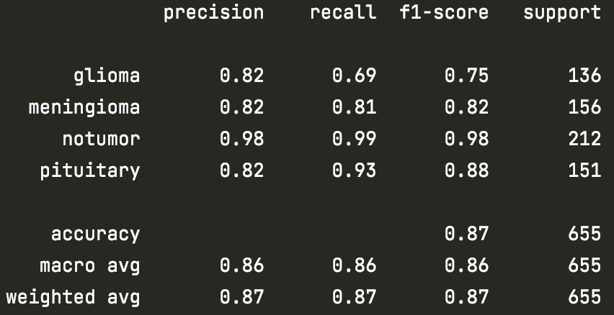

FNN 128 Dense 0.2 Dropout

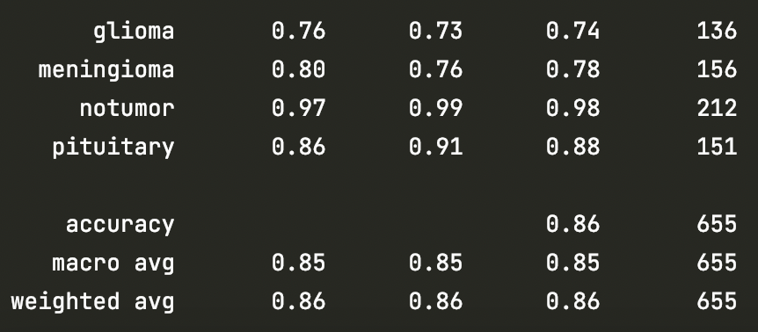

FNN 128 Dense 0.4 Dropout

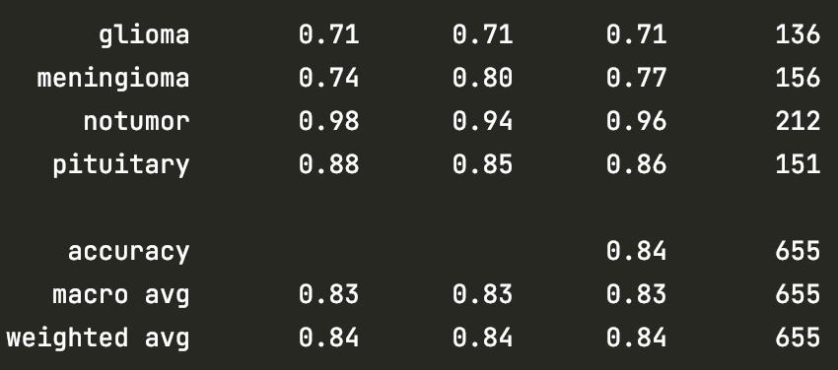

FNN 80 Dense 0.2 Dropout

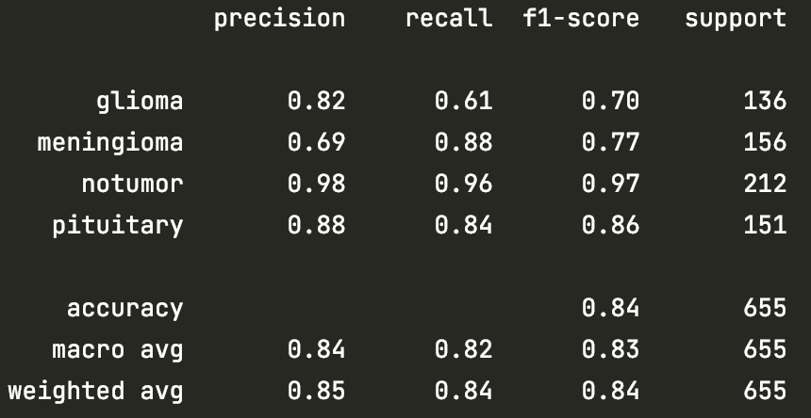

FNN 80 Dense 0.4 Dropout

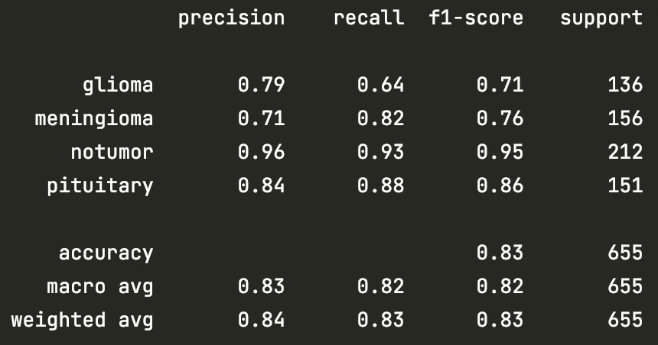

92 epochs 80 Dense

CNN model

tf.keras.layers.Conv2D(16, (3,3), input_shape=(image_size, image_size, 1), activation='relu'),  
  
tf.keras.layers.Flatten(),  
  
tf.keras.layers.Dense(units= 16, activation='relu'),  
tf.keras.layers.Dropout(0.2),

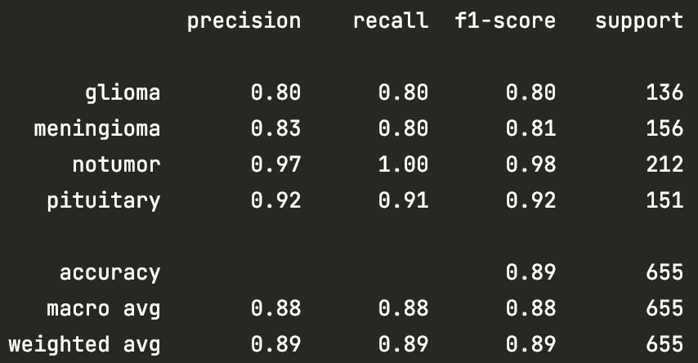

Added MaxPooling2D

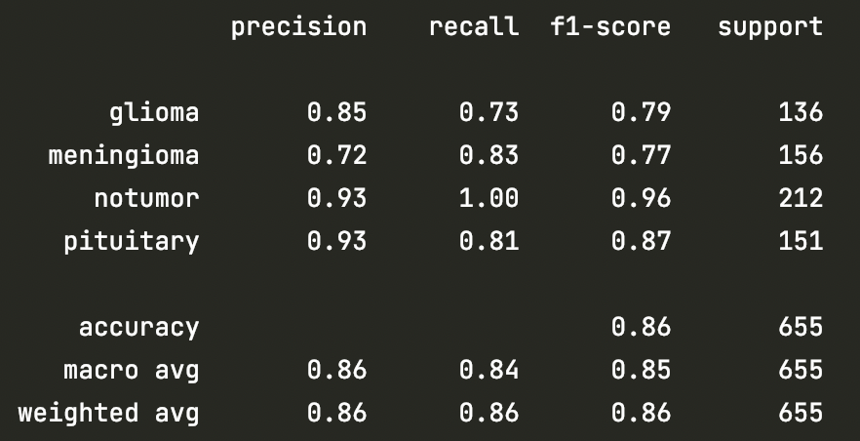

# Convolutional layer 1  
tf.keras.layers.Conv2D(16, (3,3), input_shape=(image_size, image_size, 1), activation='relu'),  
  
tf.keras.layers.MaxPooling2D(),  
tf.keras.layers.Flatten(),  
  
tf.keras.layers.Dense(units=80, activation='relu'),  
tf.keras.layers.Dropout(0.2),  
tf.keras.layers.Dense(units=len(labels), activation='softmax'),

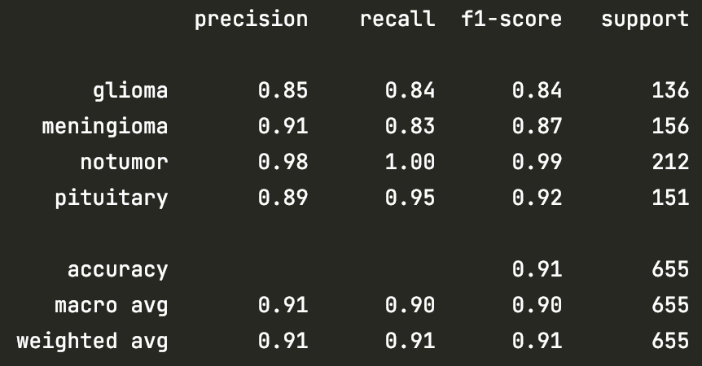

tf.keras.layers.Conv2D(64, 3, padding='same', activation='relu'),  
tf.keras.layers.MaxPooling2D(),  
tf.keras.layers.Flatten(),  
tf.keras.layers.Dense(128, activation='relu'),  
tf.keras.layers.Dense(len(labels), activation='softmax')

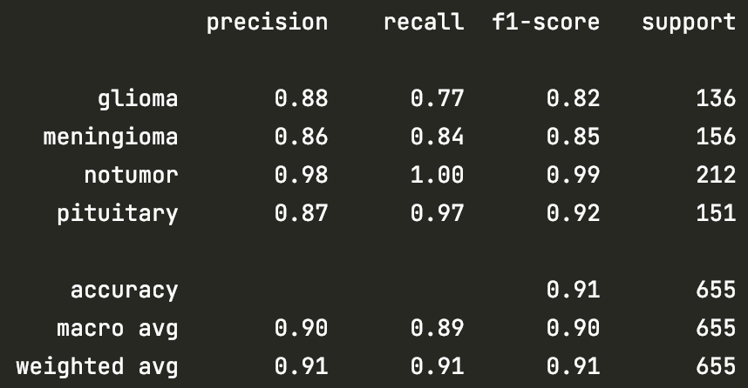

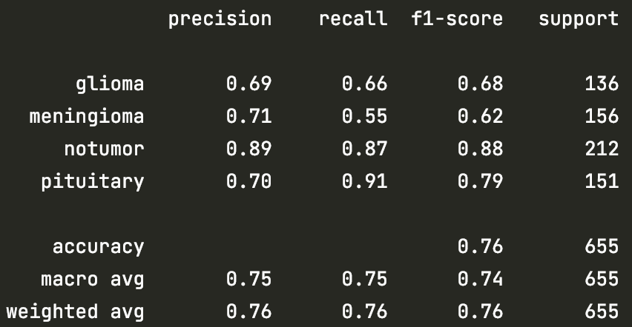

tf.keras.layers.Conv2D(filters = 64, kernel_size = (3, 3),  
 input_shape = (image_size, image_size, 1), activation = "relu"),  
tf.keras.layers.MaxPooling2D(pool_size = (6,6)),  
tf.keras.layers.Conv2D(filters = 32, kernel_size = (3, 3), activation = "relu"),  
tf.keras.layers.MaxPooling2D(pool_size = (6,6)),  
tf.keras.layers.Flatten(),  
tf.keras.layers.Dense(units = 128, activation = "relu"),  
tf.keras.layers.Dense(units = len(labels), activation = "softmax")

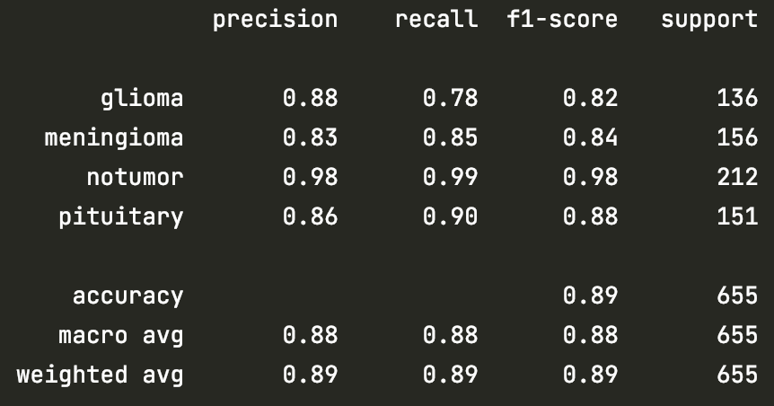

tf.keras.layers.Conv2D(filters = 16, kernel_size = (3, 3),  
 input_shape = (image_size, image_size, 1), activation = "relu"),  
tf.keras.layers.MaxPooling2D(pool_size = (6,6)),  
tf.keras.layers.Conv2D(filters = 64, kernel_size = (3, 3), activation = "relu"),  
tf.keras.layers.MaxPooling2D(pool_size = (6,6)),  
tf.keras.layers.Flatten(),  
tf.keras.layers.Dense(units = 80, activation = "relu"),  
tf.keras.layers.Dense(units = len(labels), activation = "softmax")

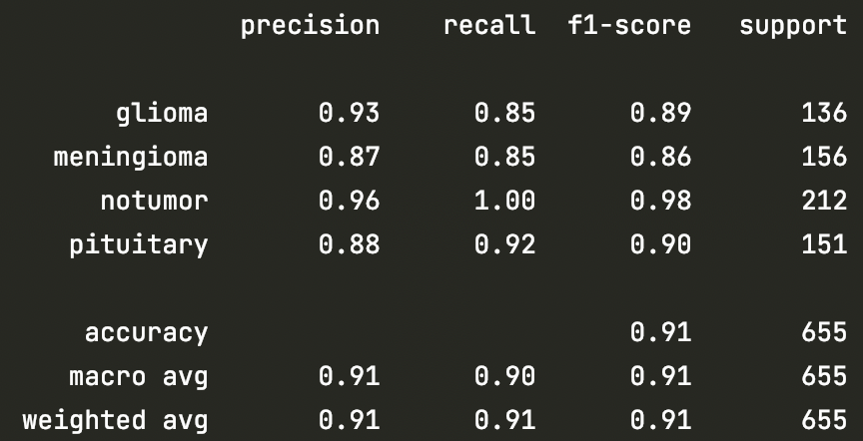

125 epochs

tf.keras.layers.Conv2D(filters=16, kernel_size=(3, 3),  
 input_shape=(image_size, image_size, 1), activation="relu"),  
tf.keras.layers.MaxPooling2D(pool_size=(6, 6)),  
tf.keras.layers.Conv2D(filters=32, kernel_size=(3, 3), activation="relu"),  
tf.keras.layers.MaxPooling2D(pool_size=(6, 6)),  
tf.keras.layers.Flatten(),  
tf.keras.layers.Dense(units=80, activation="relu"),  
tf.keras.layers.Dense(units=len(labels), activation="softmax")

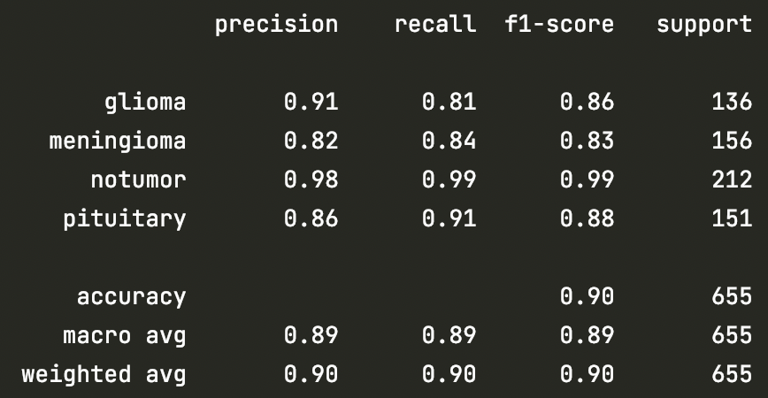

tf.keras.layers.Conv2D(filters=32, kernel_size=(3, 3), activation="relu"),  
tf.keras.layers.MaxPooling2D(pool_size=(6, 6)),  
tf.keras.layers.Flatten(),  
tf.keras.layers.Dense(units=80, activation="relu"),  
tf.keras.layers.Dense(units=len(labels), activation="softmax")

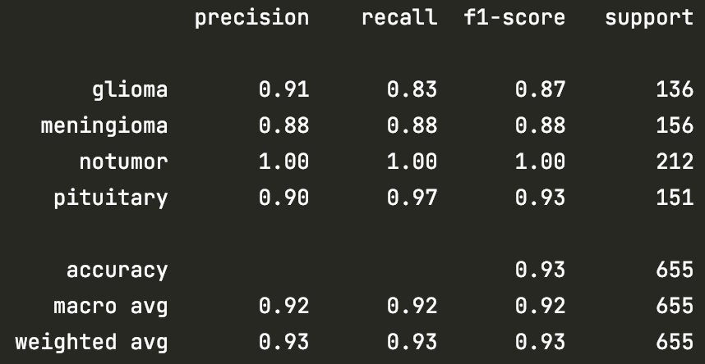

tf.keras.layers.Conv2D(filters=64, kernel_size=(3, 3), activation="relu"),  
tf.keras.layers.MaxPooling2D(pool_size=(6, 6)),  
tf.keras.layers.Flatten(),  
tf.keras.layers.Dense(units=80, activation="relu"),  
tf.keras.layers.Dense(units=len(labels), activation="softmax")

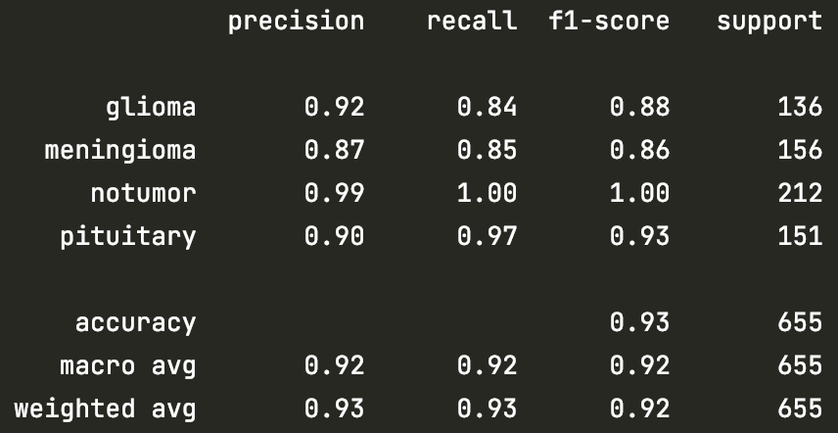

tf.keras.layers.Conv2D(filters=16, kernel_size=(3, 3), activation="relu"),  
tf.keras.layers.MaxPooling2D(pool_size=(6, 6)),  
tf.keras.layers.Flatten(),  
tf.keras.layers.Dense(units=80, activation="relu"),  
tf.keras.layers.Dense(units=len(labels), activation="softmax")

Run 1

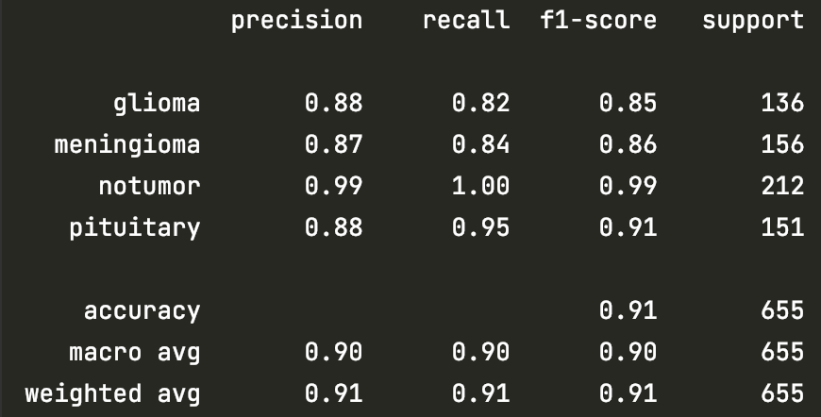

Run 2



